Running Your First Docker Container SOP



Table of Contents

1. Running Your First Docker Container 3
1.1 Description 3
1.2 Architecture Diagram 3
1.3 Lab Steps 4
1.4 Supporting References 4

Running Your First Docker Container

Description
Docker Engine is an open source containerization technology for building and containerizing your applications. In this usecase, docker engine is installed in a Linux distribution.

Architecture Diagram
The diagram below displays a visual representation of the application architecture:
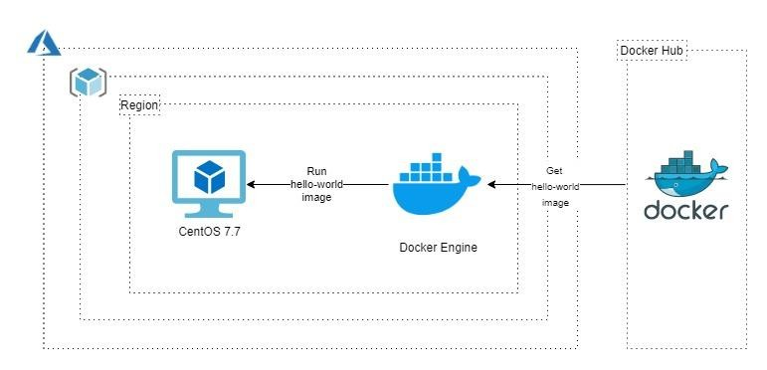

Lab Steps
Follow the steps outlined below to achieve the objective of this lab exercise:

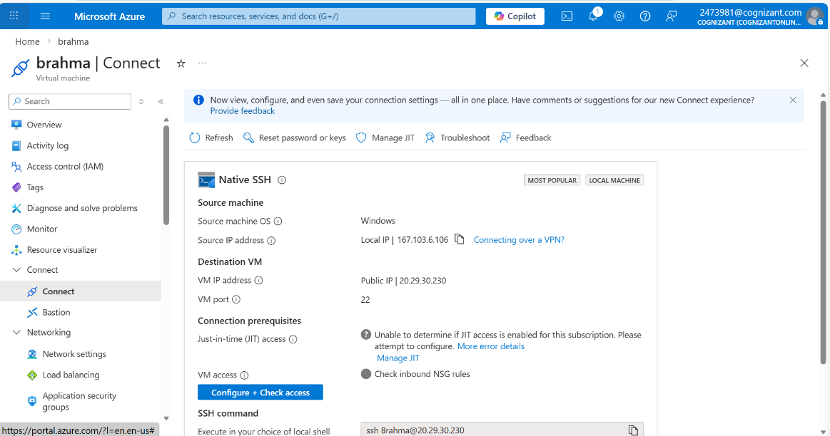
- Go to the Azure Portal and create an Ubuntu 18.04 VM.

- Update the VM:
sudo apt-get update
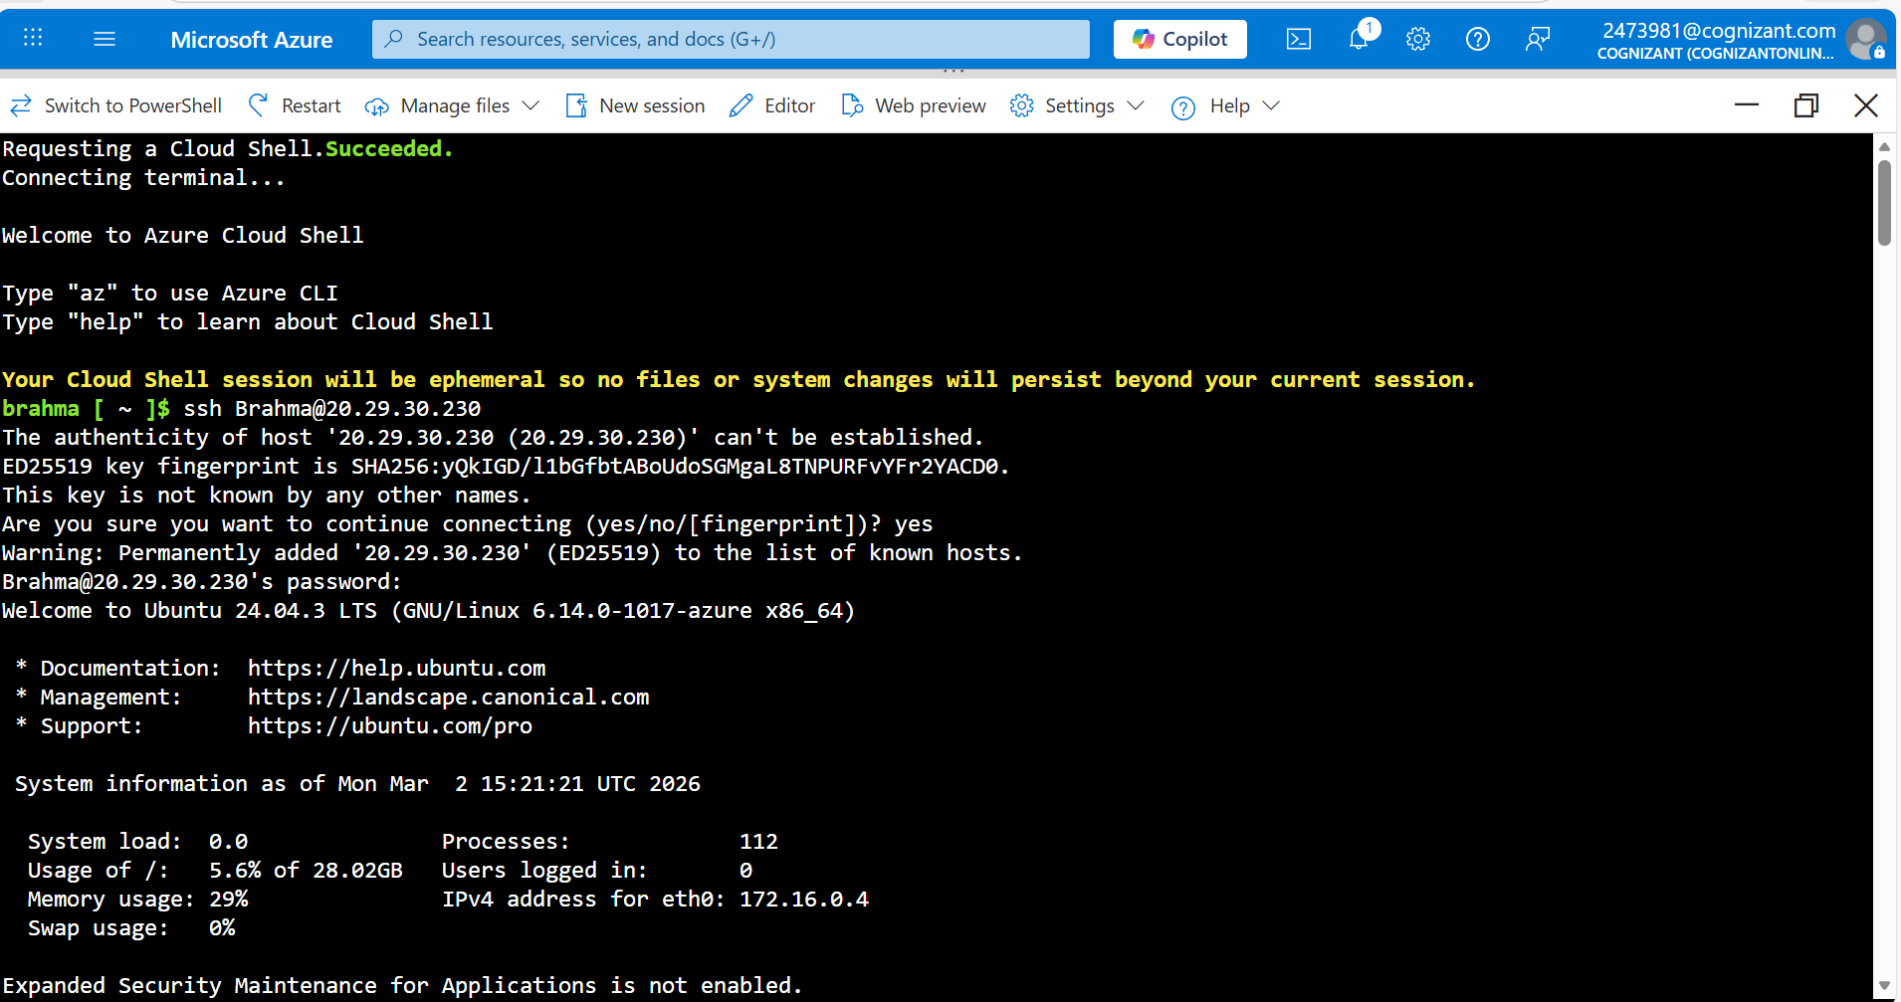
- Install prerequisite packages:

sudo apt-get install apt-transport-https ca-certificates curl gnupg lsb-release
- Add Docker’s GPG Key:
curl -fsSL https://download.docker.com/linux/ubuntu/gpg | sudo gpg --dearmor -o
/usr/share/keyrings/docker-archive-keyring.gpg
- Add the Docker Repository:

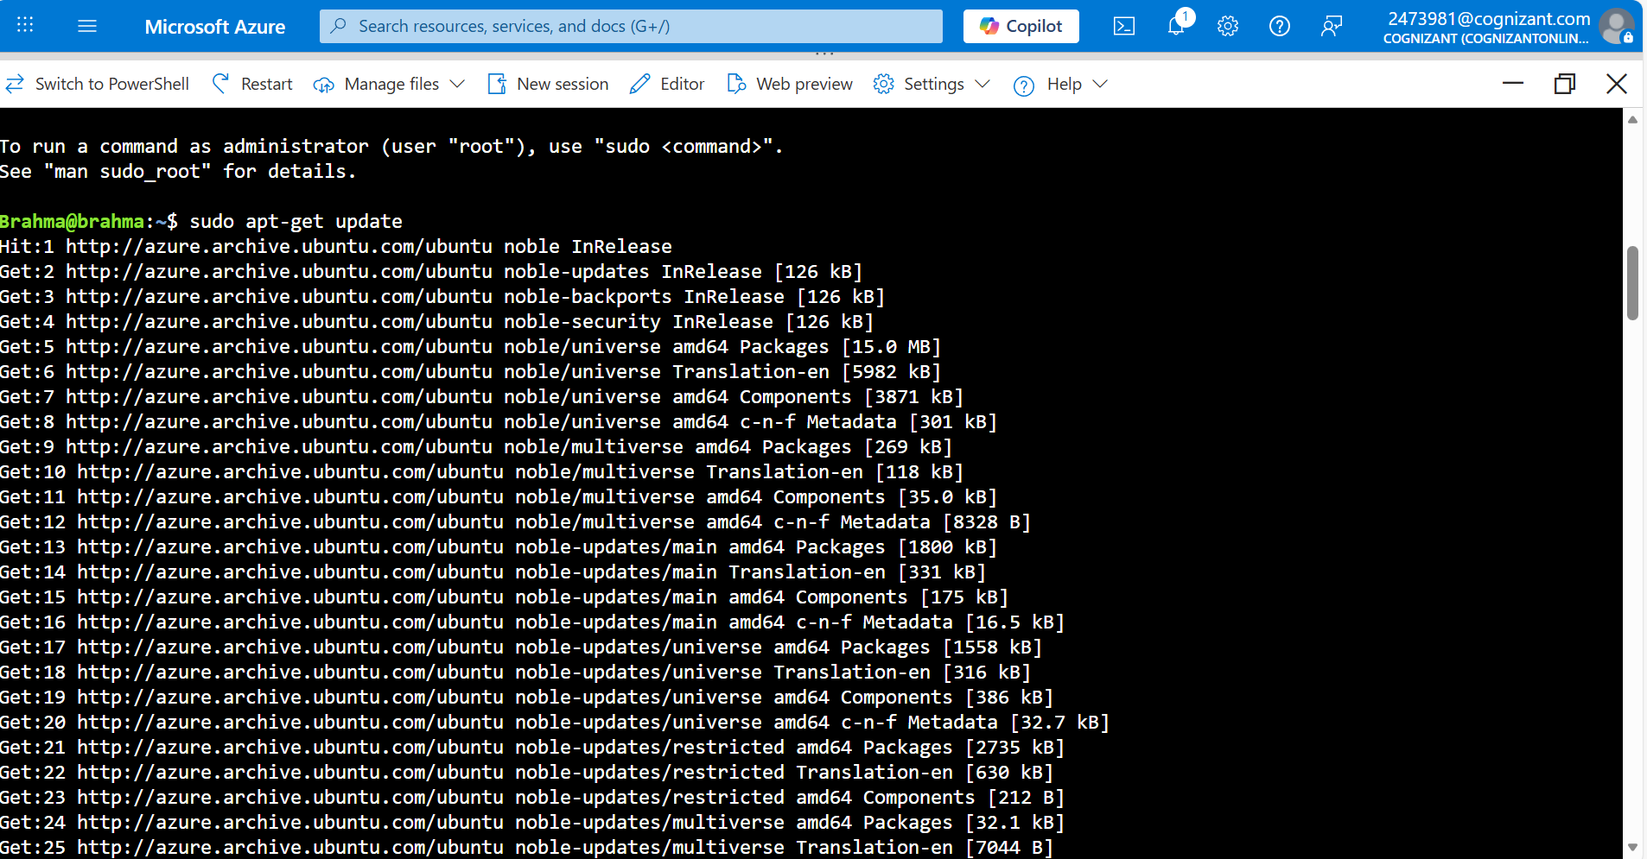
echo "deb [arch=amd64 signed-by=/usr/share/keyrings/docker-archive-keyring.gpg] https://download.docker.com/linux/ubuntu $(lsb_release -cs)

stable" | sudo tee
/etc/apt/sources.list.d/docker.list > /dev/null
- Update the repo to reflect:
sudo apt-get update
- Install Docker Engine:
sudo apt-get install docker-ce docker-ce-cli containerd.io
- Check if docker is correctly installed or not:
sudo docker run hello-world
Note: For any issues with the commands, refer the link in Supporting References section.

Supporting References
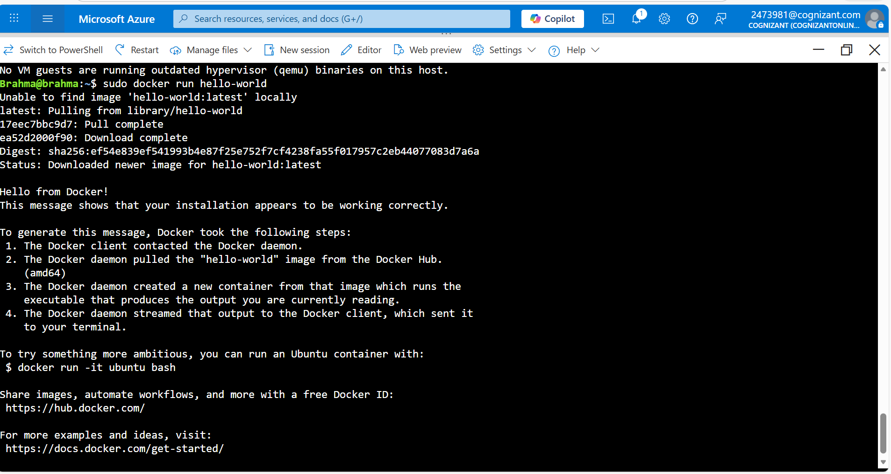
Refer the below link for additional information:

1. https://docs.docker.com/engine/install/ubuntu/

